|  |
| --- |
|  |
| QF4102 Assignment 2 Report |
|  |
| Financial Modeling |

**Prepared by: Meng Xiang**

2016-10-23

QF4102 Assignment 2 Report

Financial Modeling

All scripts/codes can be found in the appendix and the rar file.

# Section 1

1. In this part, we apply the two-state-variable FSGM with linear interpolation to price an American floating-strike arithmetic-average call option which was not newly issued.

Results are shown as follows:

When $ρ=1/2$,

|  |  |  |  |
| --- | --- | --- | --- |
| N | 40 | 80 | 160 |
| Value | 0.1090 | 0.1109 | 0.1118 |
| Time(s) | 0.0347 | 0.2749 | 2.2370 |

When $ρ=1/3$,

|  |  |  |  |
| --- | --- | --- | --- |
| N | 40 | 80 | 160 |
| Value | 0.1090 | 0.1108 | 0.1118 |
| Time(s) | 0.0542 | 0.4343 | 3.5160 |

When $ρ=1/4$,

|  |  |  |  |
| --- | --- | --- | --- |
| N | 40 | 80 | 160 |
| Value | 0.1089 | 0.1108 | 0.1118 |
| Time(s) | 0.0673 | 0.5638 | 4.5675 |

In order to see the relationship clearly, we also plot the values for different $ρ$:

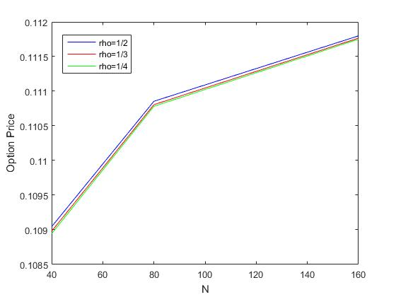

From the table and graph above, we may observe that:

1. Under same $ρ$, when N increases, the value increases and converges to 0.1118. Time for computation increases greatly. Increasing N is to discretize time more precisely, so the result is tending more closely to the correct value, and hence the time taken are longer.
2. For the same N, when $ρ$ decreases, the value decreases slightly but more converged to 0.1118. Time required to compute the result increased a bit. Increasing $ρ$ is to separate the simulated average into more pieces, so the result is tending more closely to the correct value, and hence the time taken are longer.
3. Based on the result above, we may conclude the final value is around 0.1118.

Please check the appendix or the code “Arith_FSGM_American.m” for the detail code, and please refer to “A2_1_i.m” for the implementation and test.

1. In this part, we apply the two-state-variable FSGM to price American floating strike lookback put option which was not newly issued.

Results are shown as follows:

|  |  |  |  |  |
| --- | --- | --- | --- | --- |
| N | 60 | 120 | 240 | 480 |
| Value | 0.2948 | 0.2980 | 0.3003 | 0.3020 |
| Time(s) | 0.0122 | 0.0913 | 0.7537 | 6.7509 |

We also plot the graph:

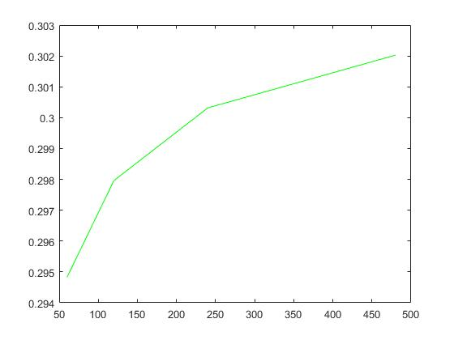

From the table and graph above, we may observe that:

1. When N increases, the value increases and converges to 0.3020. Time for computation also increases greatly. Intuitively, increasing N is to discretize time more precisely, so the result is tending more closely to the correct value. And for the same reason, the time taken are becoming longer.
2. Based on the result above, we may conclude the final value is around (or above) 0.3020.

# Section 2

In this section, we will price European vanilla options using the explicit difference scheme for the transformed Black-Scholes PDE.

Results are shown as follows:

When dx = 0.05, xmin = -5 and xmax = 2, call option price is 0.1492, put option price is 0.0053.

When dx = 0.025, xmin = -5 and xmax = 2, call option price is 0.1641, put option price is 0.0041.

In addition, the exact prices are 0.16059 and 0.00438 respectively.

Comparing two results we obtained, we conclude that when the range of x is kept same, decrease of dx (increase of no. of intervals) leads finite difference results to approach our exact prices.

# Appendix: Screen shot of scripts

## A2.1(i):

##### Function:

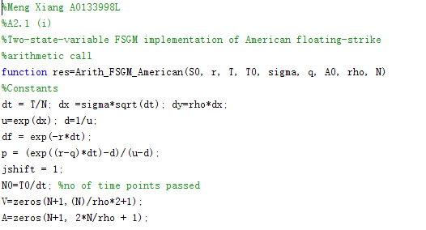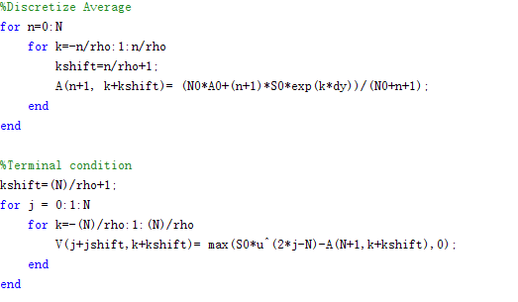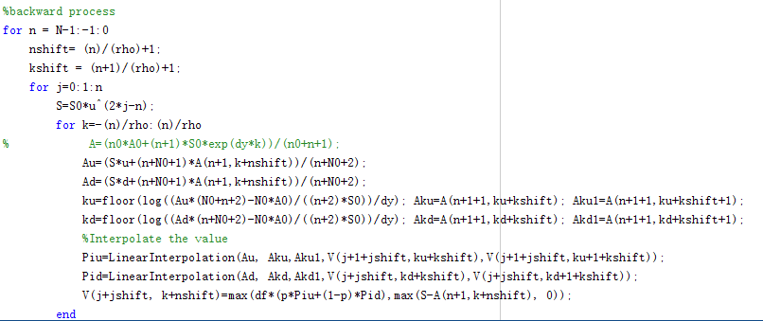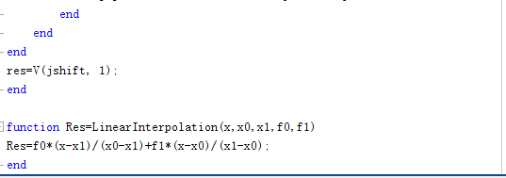

##### Implementation:

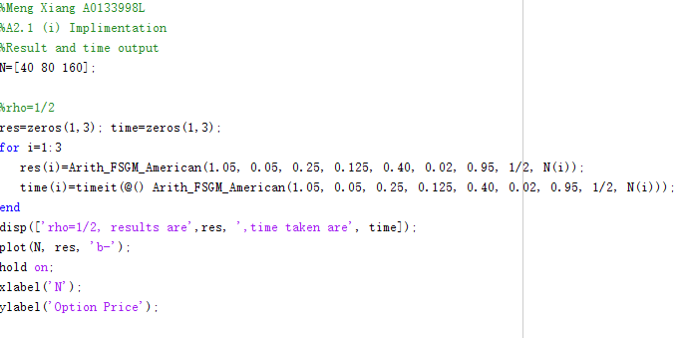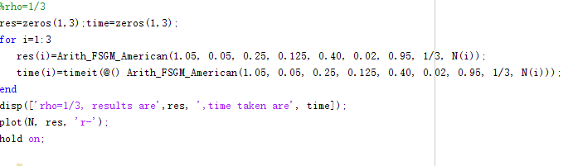

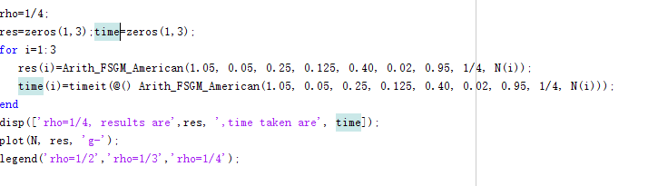

## A2.1(ii):

##### Function:

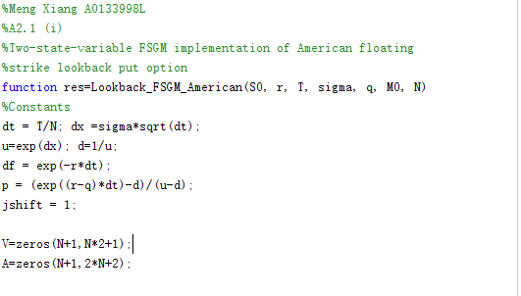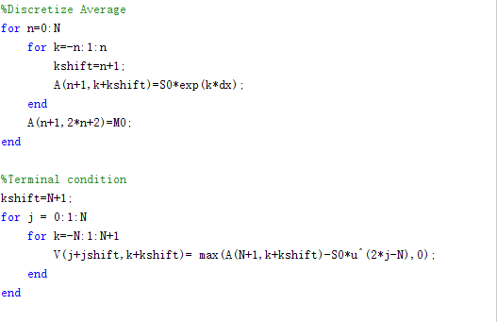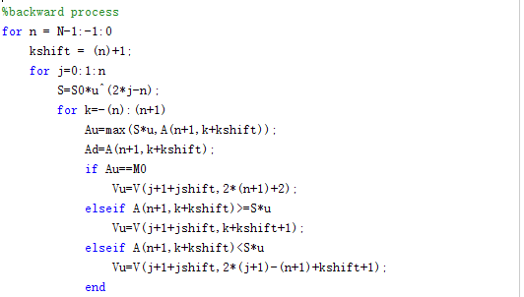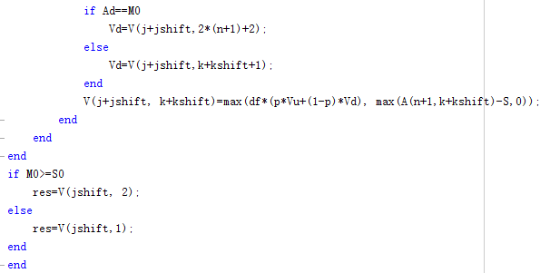

##### Implementation:

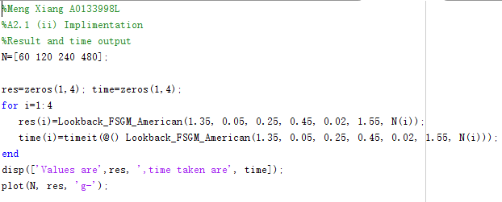

## A2.2:

##### Function:

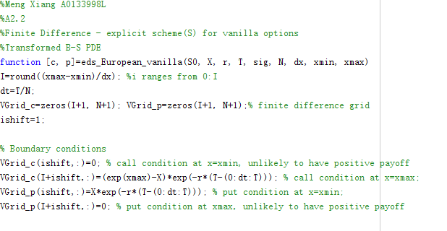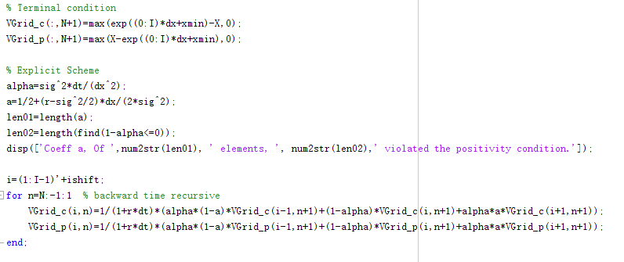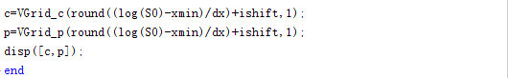

##### Implementation:

